Decentralized Patient Provenance POC
Architecture & Build Plan — Evaluation of Google Cloud Healthcare API Fit
Project #85 companion document

1. Purpose of This Document
The source concept paper ("Global Private Health Records") proposes a zero-knowledge, unindexed, dual-biometric-key architecture for humanitarian patient records, deliberately rejecting the centralized, searchable FHIR-store pattern used by mainstream tools. Feedback on the concept suggested evaluating Google's Cloud Healthcare API as a potential building block for the overall product. This document (a) evaluates that fit, (b) proposes a high-level architecture for a proof-of-concept (POC), and (c) lays out milestones, risks, dependencies, and open considerations for building it.

2. Evaluation: Is Google Cloud Healthcare API a Good Fit?

2.1 What the API Actually Provides
The referenced course teaches Google Cloud Healthcare API, a managed service that ingests and stores data in FHIR, HL7v2, and DICOM formats inside a Google Cloud project, and connects that stored data to Cloud Dataflow (streaming processing), BigQuery (analytics), and Vertex AI / TensorFlow (ML training), plus a de-identification API for stripping PHI before analytics. In short: it is a centralized, cloud-hosted, searchable FHIR/HL7v2/DICOM repository with enterprise tooling wrapped around it.

2.2 Where It Conflicts With the Core Design
The concept paper's entire value proposition rests on eliminating a discoverable, centralized patient index, so that a server breach or seizure exposes only unreadable, unlinked noise rather than a patient registry. Cloud Healthcare API is architecturally the opposite of that: it is, by design, a centralized FHIR store with a query-able 'Patient' resource index (supporting operations like Patient/$match), hosted in a Google-controlled cloud region under Google's and that region's jurisdiction.

2.3 Where It Can Still Add Value (Narrow, Bounded Uses)
The API is genuinely useful for adjacent, non-sovereign-store tasks, and can safely accelerate parts of the POC if kept out of the patient-data path:
- FHIR conformance sandbox: validating that fragment schemas produced by the local assembler are well-formed FHIR (allergies, immunizations, conditions) during development, using synthetic test patients only.
- HL7v2-to-FHIR mapping reference: many field clinics still emit HL7v2; the API's built-in HL7v2 ingestion/mapping tooling is a fast way to prototype conversion logic before it is reimplemented (or wrapped) for the offline edge device.
- De-identification pattern library: the API's de-identification service is a good reference implementation for a strictly optional, opt-in, aggregate-only reporting sidecar (e.g., "how many active TB cases were seen this month across sites") that never touches individually decryptable records.
- Not recommended: using the FHIR store as the persistent home of real patient fragments, using Patient/$match or any named/indexed lookup in production, or routing real biometric-derived keys or decrypted PHI through Google Cloud at any point.

2.4 Recommendation
Verdict: conditionally useful, but only as an isolated, non-PHI development and analytics sidecar not as the system of record. It can shorten the POC timeline for schema validation and analytics tooling, but it must never sit on the path between a patient's fingerprint and the encrypted fragment store. The architecture below reflects that boundary explicitly.

3. High-Level Architecture
The diagram below shows the four logical layers proposed for the POC. Layers 1–3 form the sovereign, zero-knowledge path (no centralized index at any point). Layer 4 is an explicitly isolated, optional sidecar for development and de-identified analytics — connected with dashed lines to signal it carries no real patient data in production.
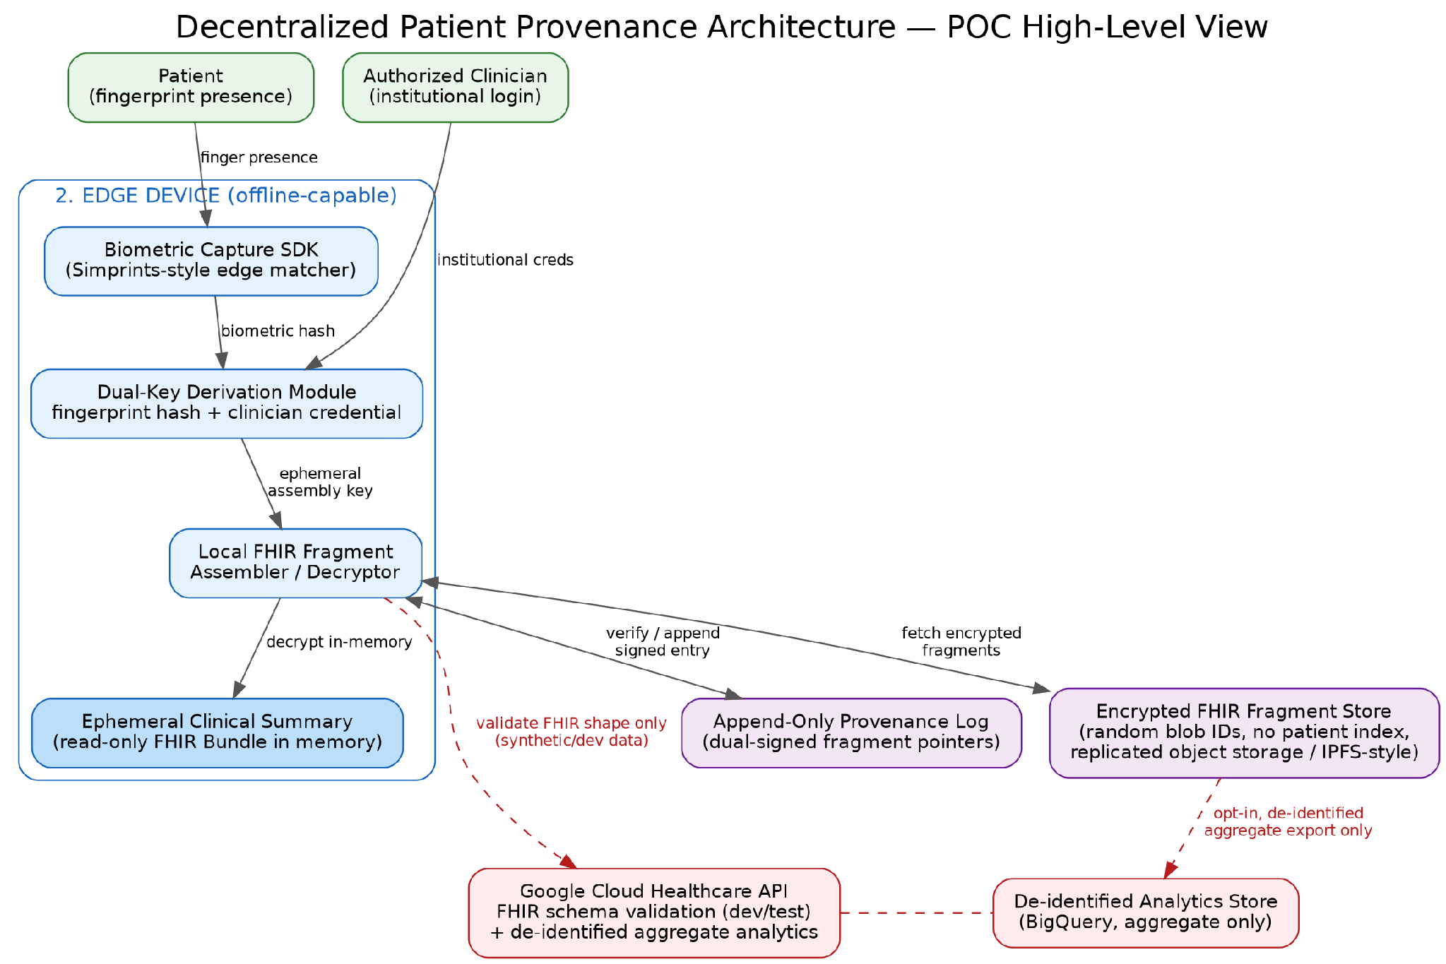
Figure 1. High-level POC architecture: field capture, edge processing, unindexed distributed storage, and isolated non-PHI sidecar.

3.1 Layer Walkthrough

Layer 1 — Field Layer
The patient presents a finger; the clinician authenticates with an institutional credential (device-level login, not tied to a central patient account). Neither action alone unlocks anything.

Layer 2 — Edge Device
An offline-capable device (rugged tablet/scanner) runs a biometric capture SDK (Simprints-style edge matching), converts the scan into a cryptographic hash, and combines it with the clinician's credential to derive a short-lived assembly key. This device also performs local decryption and, on read, holds the assembled FHIR bundle only in memory (never written to local persistent storage in cleartext).

Layer 3 — Distributed Unindexed Storage
Encrypted FHIR fragments are stored under random blob identifiers with no patient-linked index (a replicated object store or content-addressed store such as IPFS is a reasonable POC starting point). A separate append-only provenance log records dual-signed (clinician + patient-derived) pointers so additions are tamper-evident, without itself revealing what the fragments contain.

Layer 4 — Isolated Non-PHI Sidecar (optional)
Cloud Healthcare API and BigQuery are used only against synthetic/test data for FHIR validation, and, if the pilot org chooses, against de-identified aggregate exports for reporting. This boundary should be enforced technically (separate cloud project, no shared credentials or network path to Layer 2/3) and not just by policy.

4. Proposed Milestones
A staged approach lets the team validate the riskiest assumptions (biometric key derivation, offline sync, data-loss tolerance) before investing in field-hardened hardware or a real deployment.
Milestone | Goal | Key Deliverables
M0 — Feasibility Spike (2–3 wks) | Prove the crypto concept on synthetic data | Fingerprint hash → key derivation prototype; encrypt/decrypt a sample FHIR fragment; no hardware yet
M1 — Local Assembly Engine (4–6 wks) | Build the edge-device core | Local FHIR fragment assembler/decryptor; dual-key protocol (clinician login + biometric hash); ephemeral read-only bundle rendering
M2 — Unindexed Storage Layer (4–6 wks) | Stand up the distributed store | Blob store with random IDs; append-only provenance log; sync client with offline queuing and conflict handling
M3 — Hardware & Field Integration (4–8 wks) | Move off synthetic data onto real biometric hardware | Integration with a ruggedized fingerprint scanner; multi-finger fallback enrollment; degraded-scan handling
M4 — Non-PHI Sidecar (2–3 wks, parallel) | Add validation/analytics without touching the sovereign path | Cloud Healthcare API FHIR conformance tests on synthetic data; optional de-identified BigQuery reporting
M5 — Controlled Pilot (6–10 wks) | Test with a small cohort in a low-risk setting | 10–50 patient pilot at a single clinic; enrollment + multi-visit retrieval; provenance audit; ethics sign-off
M6 — Hardening & Scale Decision (ongoing) | Decide field-readiness | Threat model review; key-loss recovery procedure; legal review (esp. GDPR regions); go/no-go for multi-site rollout

5. Risks & Dependencies

5.1 Technical Risks
- Irrecoverable data loss: because the design is genuinely zero-knowledge, scarring, injury, or amputation of the enrolled finger(s) can permanently orphan a patient's history. Multi-finger fallback mitigates but does not eliminate this.
- Biometric match reliability in the field: dust, moisture, and skin conditions common in humanitarian settings degrade fingerprint capture quality; false non-matches directly translate to loss of access, not just inconvenience.
- Offline sync and conflict resolution: clinics may operate disconnected for days; two clinicians appending to the same patient's timeline while offline need a deterministic, tamper-evident merge strategy.
- Key management for the assembly key: the ephemeral key must never be persisted; a bug that caches it (logs, crash dumps, swap) undermines the entire security model.

5.2 Legal / Regulatory Risks
- GDPR and similar right-to-erasure regimes conflict with an append-only, biometrically-anchored ledger; the POC should explicitly scope itself to humanitarian/crisis contexts outside such jurisdictions, as the source paper notes.
- Biometric data regulations vary sharply by country; some jurisdictions restrict fingerprint processing even when no raw image is stored.
- Cross-border data residency: even encrypted, unindexed fragments stored in cloud infrastructure may be subject to the hosting country's legal process; the storage provider and region need explicit sign-off from the non-profit's legal/ethics team.

5.3 Organizational / Ethical Risks
- Informed consent for biometric enrollment must be understandable to displaced or crisis-affected populations, including what happens if the reference finger is later lost.
- Dependence on a small number of specialized suppliers (e.g., Simprints-class SDKs, rugged scanner vendors) creates supply and support risk for a non-profit budget.
- Reviewer / ethics-board approval timelines for a novel biometric-consent model can be longer than for a conventional EHR pilot.

5.4 Dependencies
- A working biometric SDK with edge-matching and hashing capability (Simprints or equivalent) and a compatible device.
- A distributed storage backend decision (self-hosted replicated object store vs. IPFS-class network vs. commercial object storage) — this choice has direct security and cost implications.
- Clinician-side identity/credentialing system for the institutional half of the dual-key protocol (can start simple: per-device signed credentials).
- If the Layer 4 sidecar is used: a Google Cloud project, IAM boundary, and a strict no-PHI data-handling policy enforced technically, not just procedurally.

6. Additional Considerations
- Governance: define who can authorize new clinics/devices to join the network (a rogue device with a valid-looking credential is a bigger risk here than in a centrally administered EHR).
- Recovery procedure: design and document the multi-finger fallback and any "break glass" process for lost biometric access before piloting, not after.
- Interoperability: even though the store is unindexed, the FHIR fragments themselves should stay conformant so that, when a patient consents to hand a printed/exported summary to a conventional EHR (e.g., OpenMRS), it can be ingested normally.
- Monitoring without violating the model: normal EHR operational monitoring (usage patterns, error rates) doesn't map cleanly onto a store designed to reveal nothing without physical presence; the POC should define what telemetry is acceptable to collect.
- Cost model: distributed storage, device provisioning, and biometric SDK licensing costs should be modeled early, since non-profit funding cycles are typically less flexible than commercial budgets.

7. Summary

Google Cloud Healthcare API is a strong tool for the problem it was built for —centralized, standards-based clinical data at scale but that is not this project's problem. It can still earn a place in the POC as a bounded, non-PHI sidecar for FHIR validation and de-identified analytics, which can meaningfully speed up early development. The core sovereign-record path, however, should be built as its own unindexed, dual-key, encrypted-fragment system, exactly as outlined in the source concept paper, with the milestone sequence above used to de-risk the hardest assumptions (biometric reliability, key loss, offline sync) before any field pilot.s

